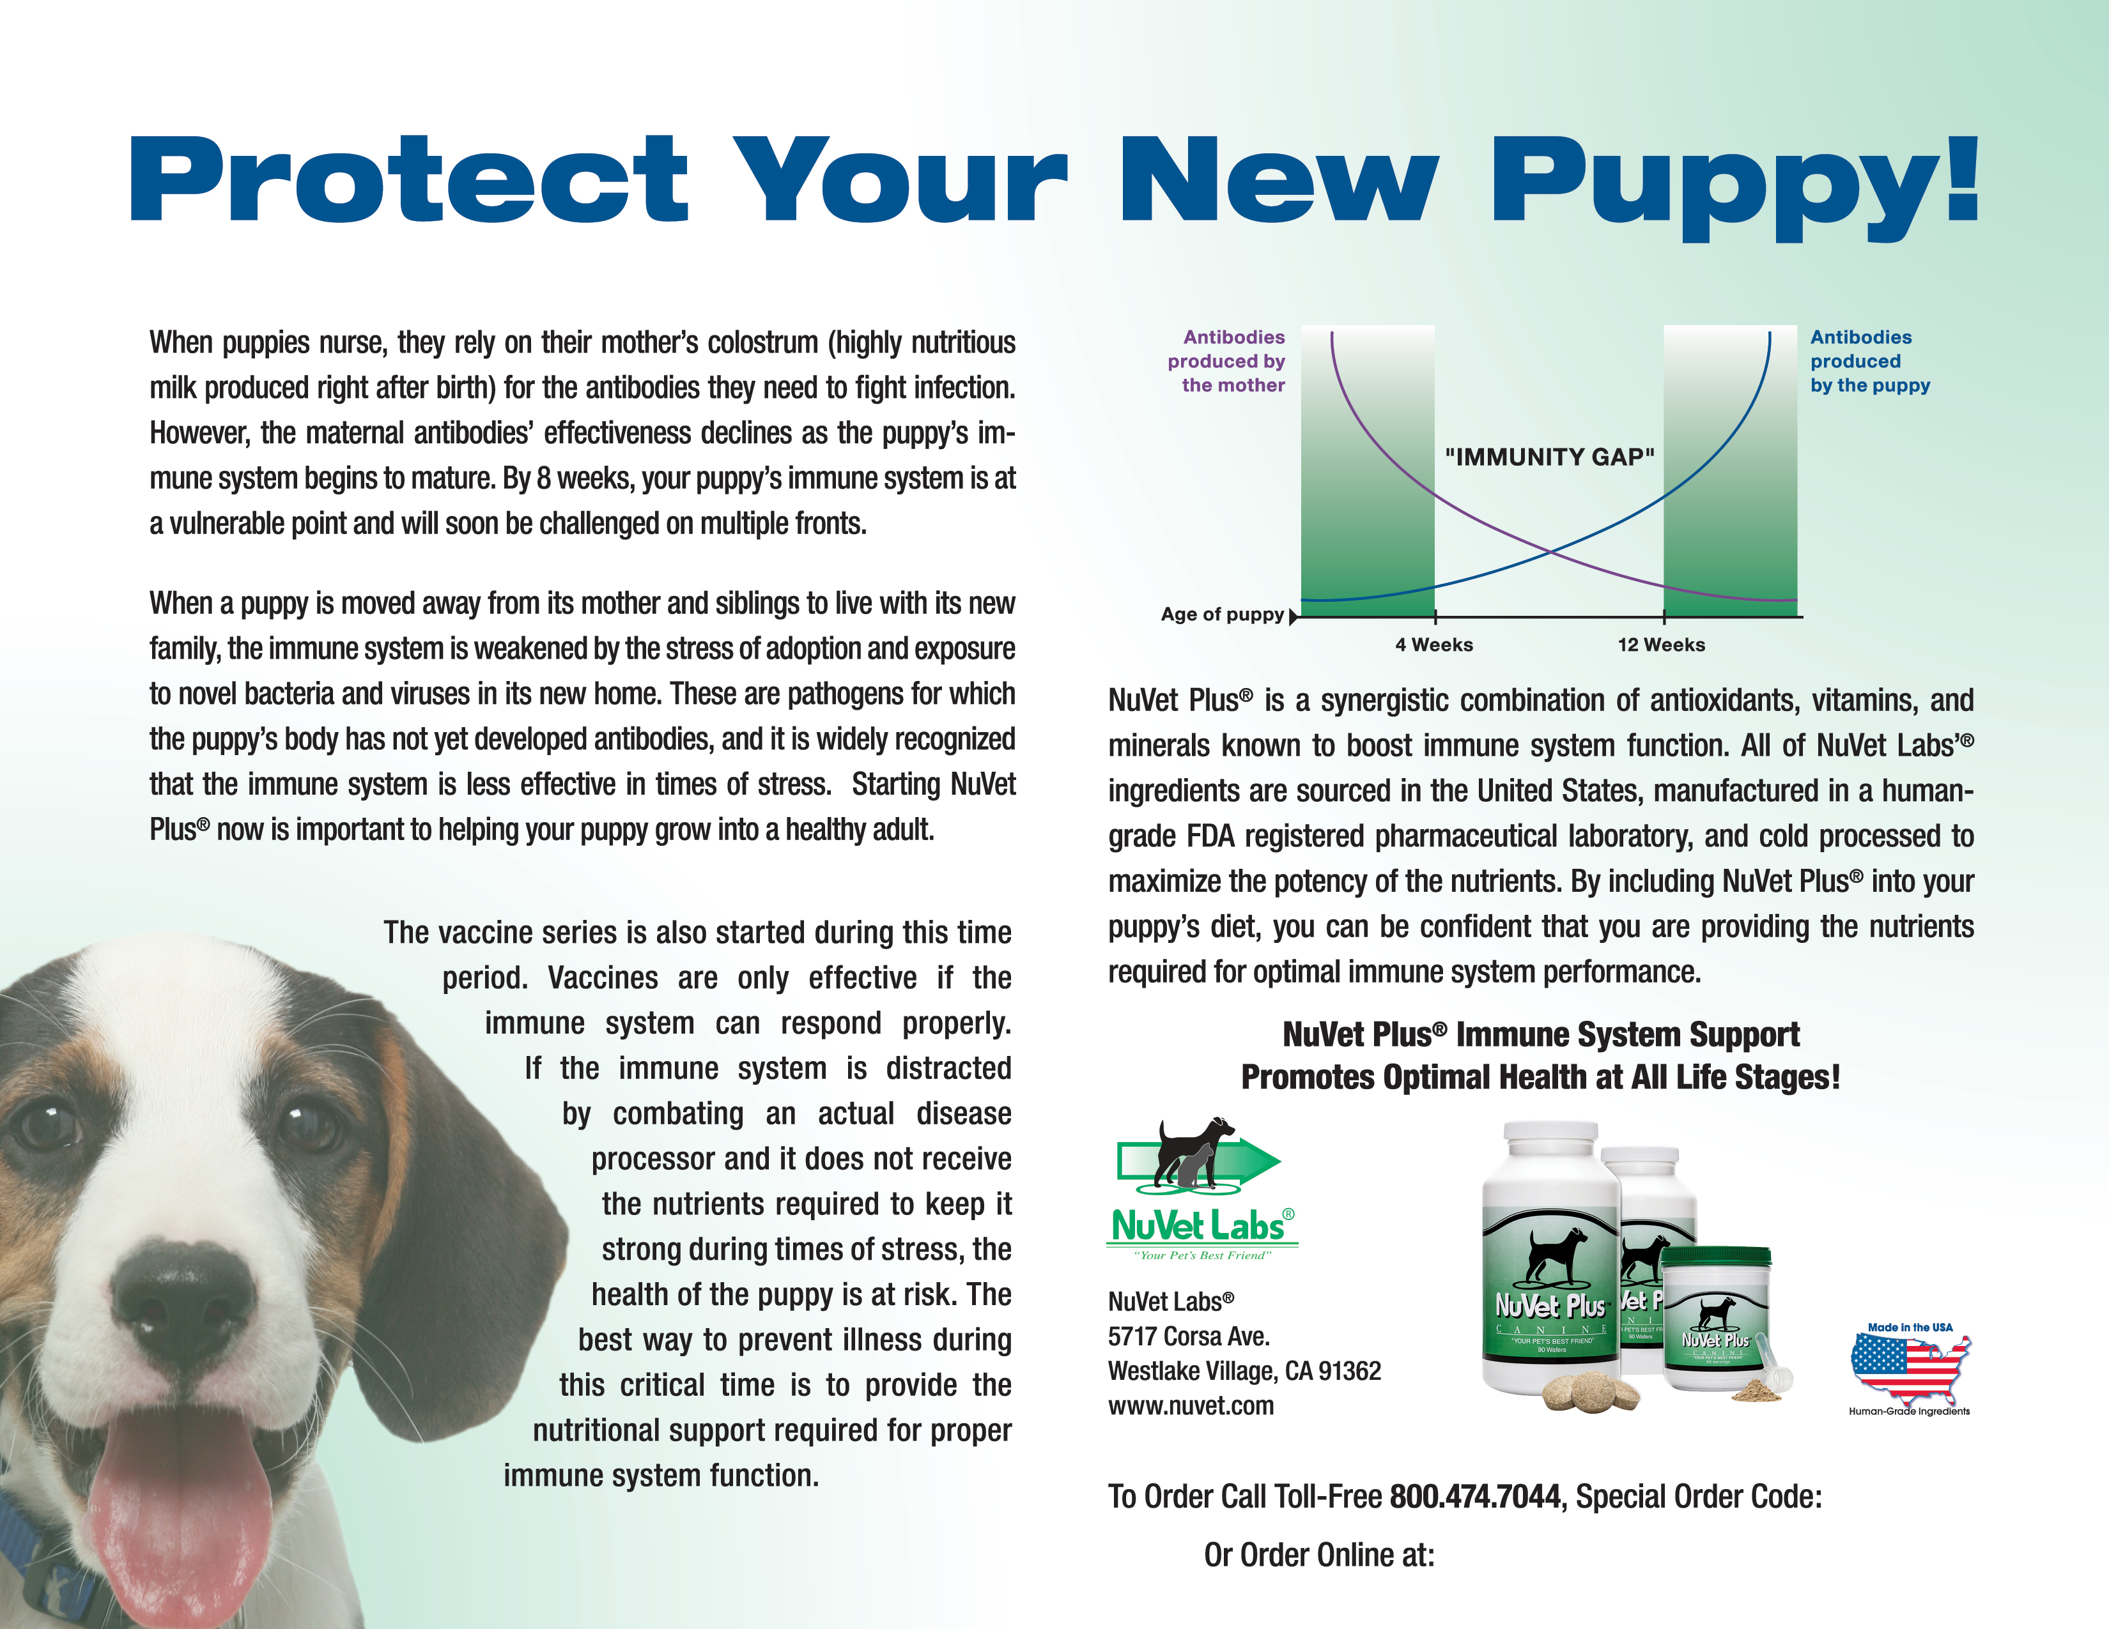
67087
www.nuvetlabs.com/67087

